Welcome to Honors English II
Megan Parrish
megan.parrish@rss.k12.nc.us
mrsmeganparrish.weebly.com

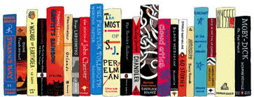

English II: World Literature
This course is an EOC course and a graduation requirement. The EOC exam will be administered online. It will include both multiple choice and constructed response questions (short answer). It will count for 25% of your grade.

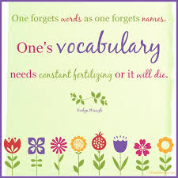
Units of Study
Vocabulary (ongoing)
Drama/Shakespeare (Macbeth)
Short Stories (African)
Novel (In the Time of the Butterflies, Things Fall Apart, The Alchemist)
Epic (excerpts from Dante’s Inferno)
Poetry ( Russian, Japanese)

Projects
- Macbeth skits
- Novel project (your choice)
- Circles of Hell (Dante)
- Research paper (MLA format)
- Multi Genre Novel (Weebly)
- Class project/presentation of your design
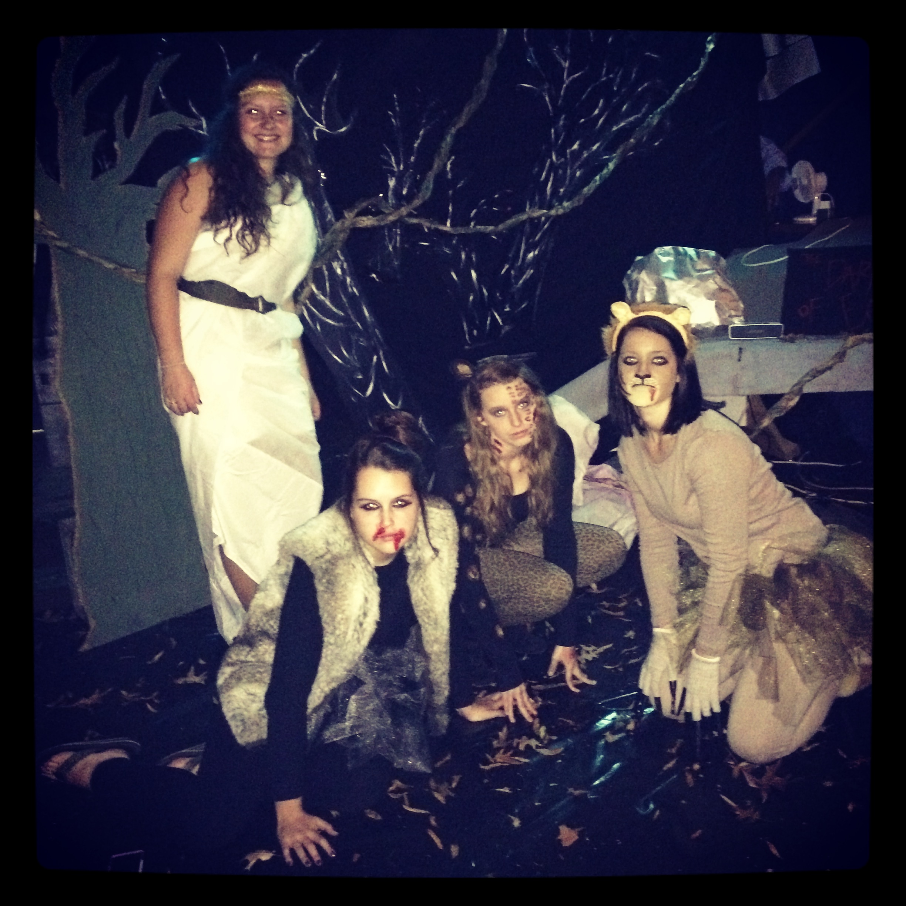
The Dark Wood of Error

Class Rules
- Be Prompt
- Be Prepared
- Be Polite
- Be Proactive

All school rules apply. The tardy policy and the dress code WILL be enforced.

Cell phones will be collected at the beginning of each block. No exceptions. ➔

Homework Expectations
Expect homework three times a week. Often, this will involve reading. We will use Edu20 (or something similar) at least once a week. If you do not have internet access at home, plan to complete your Schoology assignments before/after school in the Media Center or anywhere else with open wifi. Please see me if you anticipate this being an issue.

Grading Policy
Assignments are due when the bell rings. Late work will NOT be accepted in this class. If you are absent, ask for your make up work as soon as you return to school.

