Macbeth: Background (from www.bbc.co.uk BBC © 2014)
Political
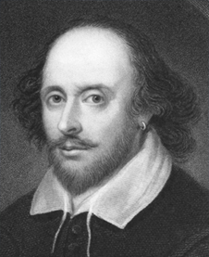
Shakespeare wrote Macbeth in 1606. It is important to understand the political context in which it was written, as that is the key to the main theme of the play, which is that excessive ambition will have terrible consequences. Shakespeare was writing for the theatre during the reigns of two monarchs, Queen Elizabeth I and King James I. The plays he wrote during the reign of Queen Elizabeth, such as A Midsummer Night's Dream, are often seen to embody the generally happy, confident and optimistic mood of the Elizabethans. However, those he wrote during James's reign, such as Macbeth and Hamlet, are darker and more cynical, reflecting the insecurities of the Jacobean period. Macbeth was written the year after the Gunpowder Plot of 1605.

When Queen Elizabeth died in 1603, she had no children, or even nephews or nieces. The throne was offered to James Stuart, James VI of Scotland, who then became James I of Britain. He was a distant cousin of Elizabeth, being descended from Margaret Tudor, the sister of Elizabeth's grandfather, Henry the Eighth.James was the son of the Catholic Mary Queen of Scots, who had been deposed and imprisoned when he was a baby, and later executed on Elizabeth's orders. Brought up by Protestant regents, James maintained a Protestant regime in Scotland when he came of age, and so was an acceptable choice for England which had become firmly Protestant under Elizabeth. However, his accession was by no means a popular choice with everyone. Since he was not a direct descendant of Elizabeth, there were other relatives who believed they also had a strong claim and James feared that discontented factions might gather around them. At first the Catholics had hoped James might support them, since his mother had been such a staunch Catholic, but when they realised this would not happen conspiracies developed, one of which was the Gunpowder Plot. Guy Fawkes and his men tried to blow up James and his parliament in 1605. The conspirators were betrayed, and horribly tortured on the rack until they confessed. They were then executed in the most brutal fashion as a warning to other would-be traitors. Shakespeare's play Macbeth is to some extent a cautionary tale, warning any other potential regicides (king-killers) of the awful fate that will inevitably overtake them.

Philosophical

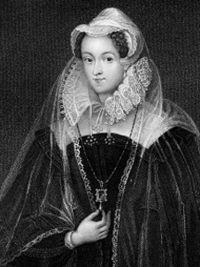
Religious thinkers in the Middle Ages had upheld the idea of 'The Great Chain of Being'. This was the belief that God had designed an ordered system for both nature and humankind within which every creature and person had an allotted place. It was considered an offence against God for anyone to try to alter their station in life. After death, however, all would be raised in the kingdom of heaven, if they respected God's will. Since royal rank was bestowed by God, it was a sin to aspire to it. This doctrine – a convenient one for King James – was still widely held in Shakespeare's day.

Although his mother, Mary Queen of Scots, was a beautiful and charming woman, James I was aware he was ugly and lacking in the charisma which inspired loyalty. But he was an intelligent and well-educated man, and espoused various beliefs which he felt would keep his position secure. One of these was the so-called 'divine right of kings'. This was the belief that the power of monarchs was given directly by God, and thus monarchs were answerable only to God. Any opposition to the King was an attack on God himself, and therefore sacrilege, the most heinous of sins. The anointing ceremony at the coronation made the King virtually divine. All the Stuart kings strongly supported the belief in their 'divine right' to rule as it was an effective safeguard of their position. They even claimed Christ-like powers of healing. In Macbeth, Shakespeare alludes to King Edward of England successfully healing the sick: 'such sanctity hath heaven given his hand'. Queen Anne was the last British monarch who used 'the Queen's touch' in this way.
Historical
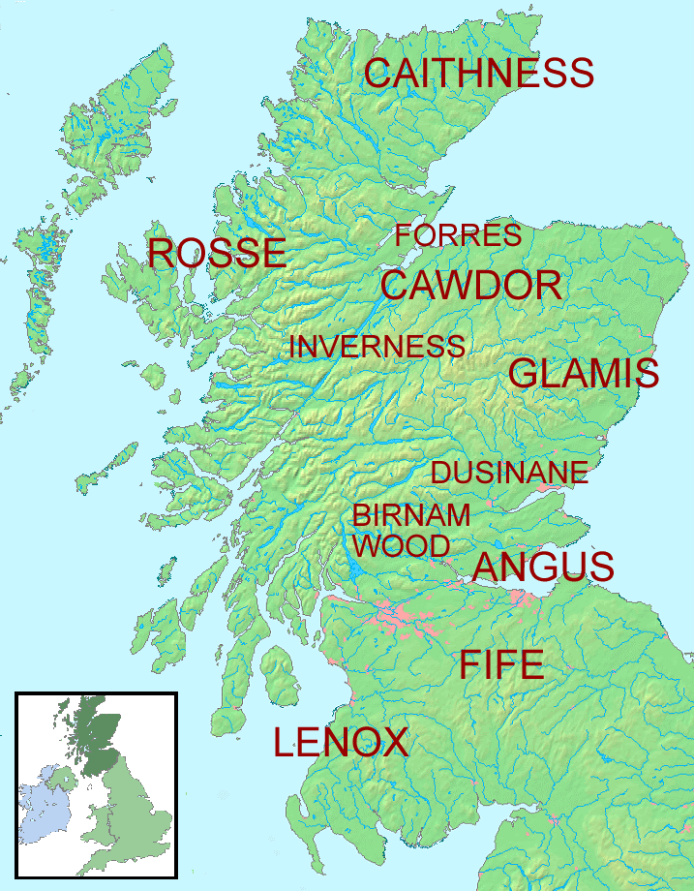
Shakespeare's plot is only partly based on fact. Macbeth was a real eleventh century Scottish king, but the historical Macbeth, who had a valid right to the throne, reigned capably in Scotland from 1040 till 1057. He succeeded Duncan, whom he had defeated in battle, but the real Duncan was a weak man, around Macbeth's own age, not the respected elderly figure we meet in the play. In reality, Macbeth was succeeded by his own stepson, not by Duncan's son, Malcolm, who came to the throne later. The Stuart kings claimed descent from Banquo, but Banquo is a mythical figure who never really existed. Shakespeare found his version of the story of Macbeth in the Chronicles of Holinshed, a historian of his own time. Holinshed does include a Banquo in his version, but he is also a traitor who assists Macbeth in the murder. As a tribute to the Stuarts, and James in particular, Shakespeare presents Banquo as a wise, noble and regal figure who arouses jealousy in Macbeth as much for his own good qualities as for the promise the witches make to him of founding a dynasty.

Shakespeare and the Court

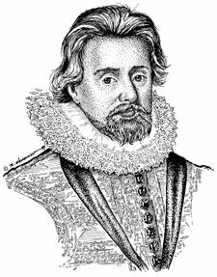
During the reign of Queen Elizabeth, Shakespeare's acting company was called the 'Chamberlain's Men', and it is known that they performed for the court. After the accession of James they changed their name to the 'King's Men' as a tribute to him. The patronage of the King and court was obviously valuable to Shakespeare. In Macbeth, Shakespeare seeks to flatter and please the King in various ways. Macbeth, the character who usurps the place of a lawful King, is shown as losing everything as a result – he becomes hated and demonised by all his subjects, as does his wife, who supports him in his crime. Banquo, whom the Stuarts claimed as their ancestor, is presented in a completely positive light. When the witches show Macbeth the future, he sees a line of kings descended from Banquo that seems to 'stretch out to the crack of doom'. This flatters King James with the promise of a long-standing dynasty, although in fact James's father, Charles I, would be executed, and the Stuart line was to die out with Queen Anne in 1714.

Shakespeare also included other enthusiasms of the King in the play. James had written a book called Basilikon Doron, which looks at the theme of kingship. In the book, James identifies the ideal king as one who does his duty to God and to his country and who is also a man of spotless personal integrity. In the play, Shakespeare, too, explores this topic, with the character of Malcolm representing the template of the ideal king. In addition, the idealised portrait of Edward the Confessor, the 'holy king' who has the power literally to heal his people, would come across to a contemporary audience as an indirect tribute to James himself. James was also very interested in the supernatural, and had written a paper called Daemonologie on the subject. During his reign as King of Scotland, James is known to have been directly involved in some witch trials at North Berwick. Women were regularly burnt as witches, and Shakespeare presents his witches unequivocally as powerful and evil emissaries of the devil. In his day, the majority of the general public, too, believed in witches and the power of the supernatural, and the witch scenes would have been taken very seriously.

