Literary Term and Figurative Language Review
Fill in the blank beside each example or definition with term that represents that concept.

1. ________________________ is a contrast between what should happen and what does happen.

2. A million people came to the West Rowan football game last night. _______________________

3. “Take a Chance” is a(n) ___________________________.

4. “The Gloved One” is an _______________________ for Michael Jackson.

5. “I met him once in kindergarten. I should have paid attention to the connection I felt then. Now we’re married.” _________________________

6. Poetry
Fiction
Non-Fiction __________________________
Play

7. “Out of the clear, blue sky” OR “Out of the blue, clear sky” is ___________________________

8. The author’s attitude is known as ____________________________

9. “Gah! This Hallmark commercial makes me cry every time!” is ___________________________

10. “No one goes to that restaurant. It’s too crowded” is a _____________________________

11. The opinion of the author is known as ____________________________
I have a goal!
12.
____________________________

13. The moral of the story or message of the story ____________________________.

14. Event #1, Event #2, Event #3

_____________________________
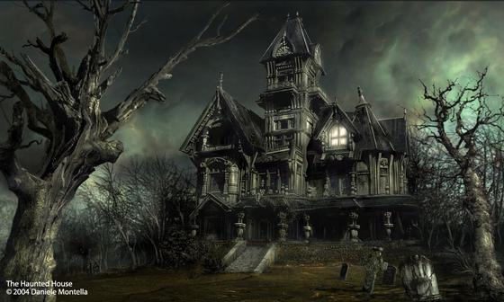
15.

________________________________

16. “I, the author, believe I will write a story about world peace.” _____________________________

17. The end of the school day is heaven. _____________________________

18. “When a clock is hungry, it goes back four seconds.” _______________________

19. “Hickory, Dickory, Doc
The mouse ran up the clock” is a _________________________

20. see- sea, flour- flower __________________________

21. “Carrie’s cat clawed her couch, creating chaos” is ______________________________
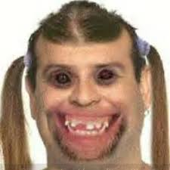
22.

____________________________

“She’s pretty ugly!”

23. Reference to another person, place, thing within a different body of work __________________________

24. Pictures created in the reader’s mind _________________________

25. “y’all” or “you guys” __________________________

Practice
Underline the figurative and/or literary terms in the poem below. What is the author’s tone, and what is the mood of the piece?

"The Cross of Snow"
Henry Wadsworth Longfellow

In the long, sleepless watches of the night,
A gentle face--the face of one long dead--
Looks at me from the wall, where round its head
The night-lamp casts a halo of pale light.
Here in this room she died, and soul more white
Never through martyrdom of fire was led
To its repose; nor can in books be read
The legend of a life more benedight.
There is a mountain in the distant West
That, sun-defying, in its deep ravines
Displays a cross of snow upon its side.
Such is the cross I wear upon my breast
These eighteen years, through all the changing scenes
And seasons, changeless since the day she died.

Tone:
Mood:

More Practice
Write a poem using literary or figurative terms on the practice sheet. There is no length requirement or required subject. Please underline the examples within the poem. Also, explain the tone and mood of your poem.

Tone:

Mood:

